**Problem 01**

Write a program that displays “Hello” in one line, and “World” in another line using exactly two (2) COUT statements.

**Solution and Testing 01**

To make use of 2 cout’s, we shall feed “Hello” to cout followed by an endl. In the next line we call cout again for “World” and a second endl after “World”.

Below is the screenshot of solution program as well as testing in the terminal.

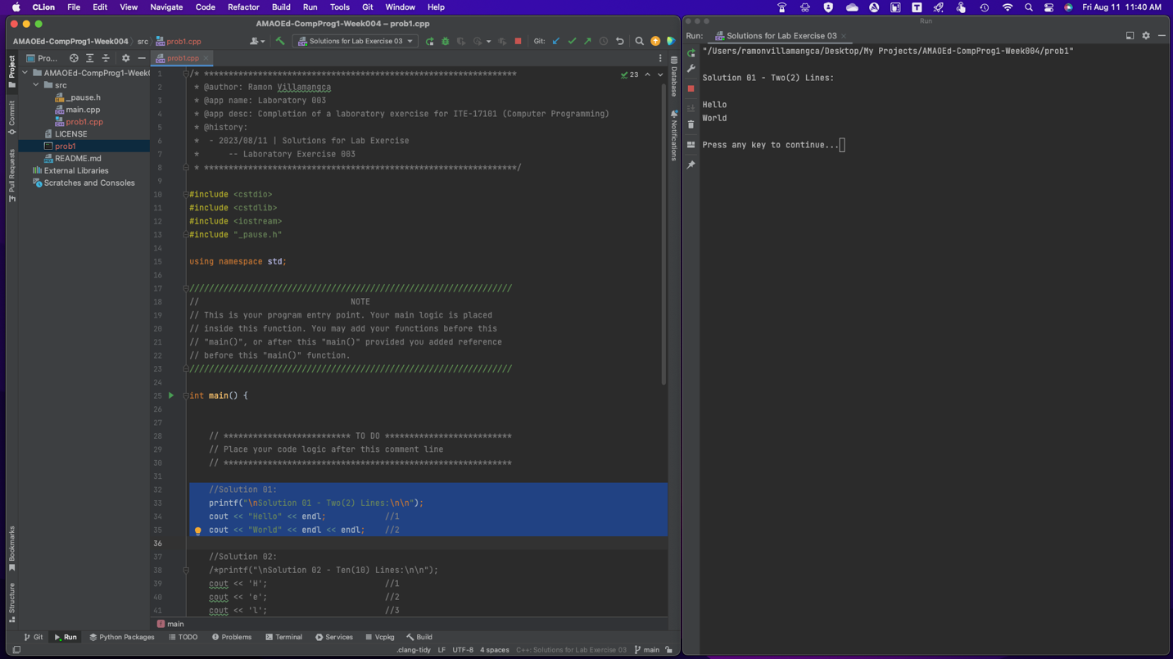

**Problem 02**

Write a program that displays “Hello” in one line, and “World” in another line using exactly ten (10) COUT statements.

**Solution and Testing 02**

Here since “Hello” and “World” already have total 10 characters, we shall call cout for all the characters. An endl shall also be added after the character ‘o’ of “Hello” and after ‘d’ of “World”.

Below is the screenshot of solution program as well as testing in the terminal.

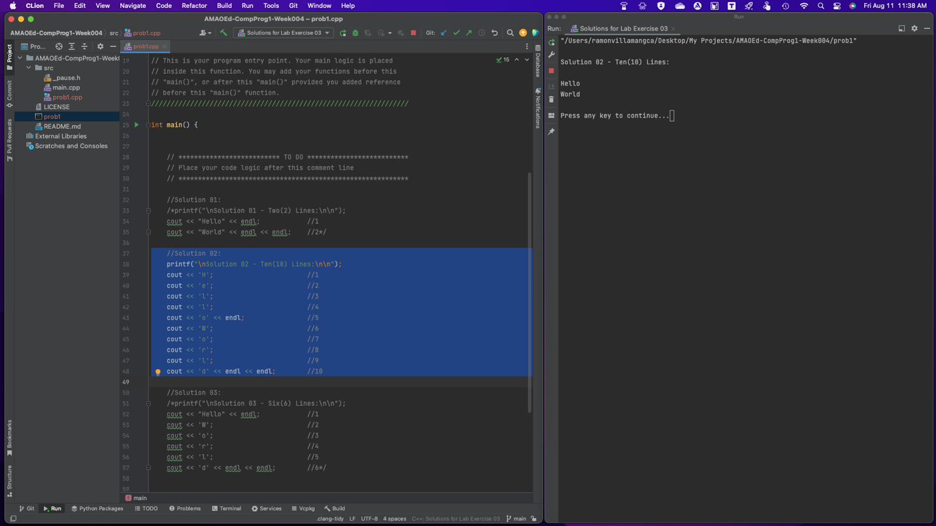

**Problem 03**

Write a program that displays “Hello” in one line, and “World” in another line using exactly one (1) for the “Hello” and exactly five (5) COUT statements for the “World”.

**Solution and Testing 03**

Here we call cout for “Hello” followed by an endl. For each character of “World”, we shall call cout. An endl shall also be added after the character ‘d’ of “World”.

Below is the screenshot of solution program as well as testing in the terminal.

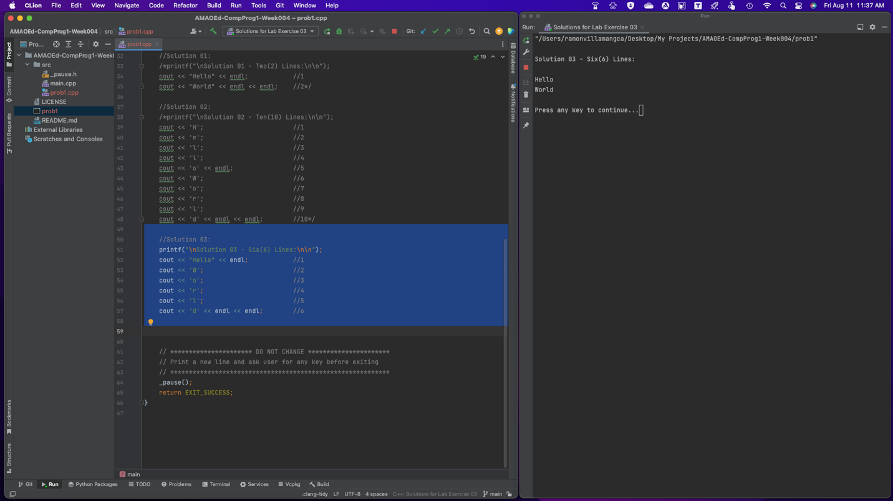

**Problem 04**

What can you conclude from this activity?

**Answer 03**

“Hello world” program has always been the default code to start with when learning to program. It is good that in this problem sets student can learn different ways to solve a problem.

------------------------

**NOTE FOR THIS PROBLEM:**

Source code can be found on my GitHub page: <https://github.com/rvillamangca/>.

